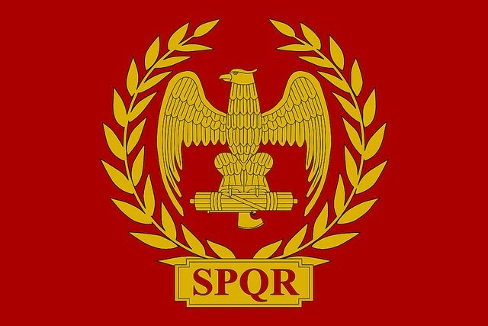
Slavery: The Roman Perspective.
Perry Las Marias.
Year 10, Phoenix Academy.
Slavery Has existed throughout history and is an illegal and outlawed and out of date practice. But in the ancient world it was a completely different story. During the age of the Pax Romana, slavery was a common and legal practice and was a driving force Of Roma’s economy and culture. Other than doing manual labour, slaves did other types of work in the empire that is very different to our contemporary knowledge of slavery and slaves and its effects on the modern world today.
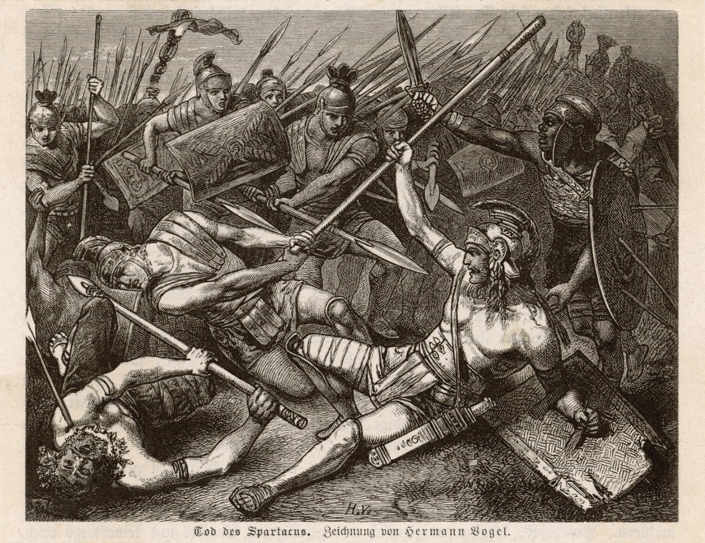( The Death of Spartacus,Hermann Vogel 1885)
One aspect of Roman Slavery that it was unique to other ancient civilisations on how a person could be enslaved. For Example, in this figure above it shows a battle between rebelling slaves and Roman legions. This is because in 73 BC a war erupted in the Roman republic between slaves and the slave system. A slave by the name of Spartacus along with tens of thousands of other slaves took up arms and waged a campaign against the Roman republic as many of the slaves were captured by pirates, a practice so persuasive that Pompey became dictator to end the fiasco. But there were many other ways to be enslaved including being a prisoner of war, captured from your homeland and brought back to Rome, the Romans marginalising a population they conquered or simply born into slavery.
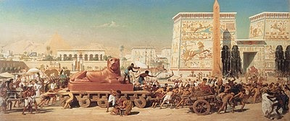(The enslavement of the Israelites from exodus)
This is very similar to another ancient civilisation. In Book nine of the Odyssey, Odysseus recalls how he captured slaves when conquering Ismara by killing all the men and taking the Women as slaves. This is also completely different to the Book of Exodus in how the Israelites became enslaved to the Egyptians through the Egyptians being antisemitic of the Israelites and marginalised the whole population of fears of their high number and strength which eventually led to the exodus led by the prophet Moses, coincidentally the Romans also marginalised populations they conquered such as Julius Ceasar conquering Gaul and marginalised the Celtic population.This shows that Roman Slavery is unique and not unique as you can become enslaved by being misfortunate and the Romans doing any means necessary to get more slaves and illustrates that theyalso use the same methods of what the Greeks and Egyptians did toget more slaves by marginalisation and piracy.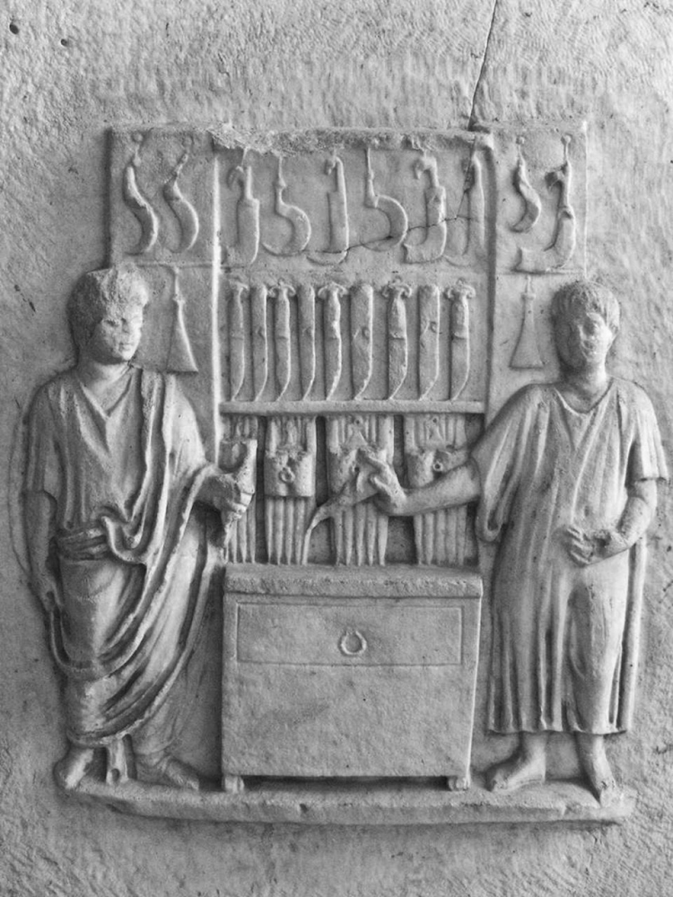 ( Grave inscription of a freed slave and his former slave master)
Another reason why Roman slavery is very unique to other ancient civilisations is their process on manumission (process on releasing slave from slavery). In the figure above it shows a grave relief featuring a freed slave (on the right) and his former slave master ( on the left) being blacksmiths. Other than manual, unskilled labour, slavery provided an apprenticeship for slaves to be productive or skilled when they assimilated into Roman society(but they cannot hold positions and only their children can). Many slaves maintained their relationships with their former slave masters who were their patrons in their trade but, freed slaves can also set up their on their own without help from their slave masters, and slaves recieve emancipation depending on how generous or brutal their slave masters were. As the roman empire progressed slaves gained legal protection over time and could file their complaints against their masters. This is very different to Another ancient civilisation: the Persians. 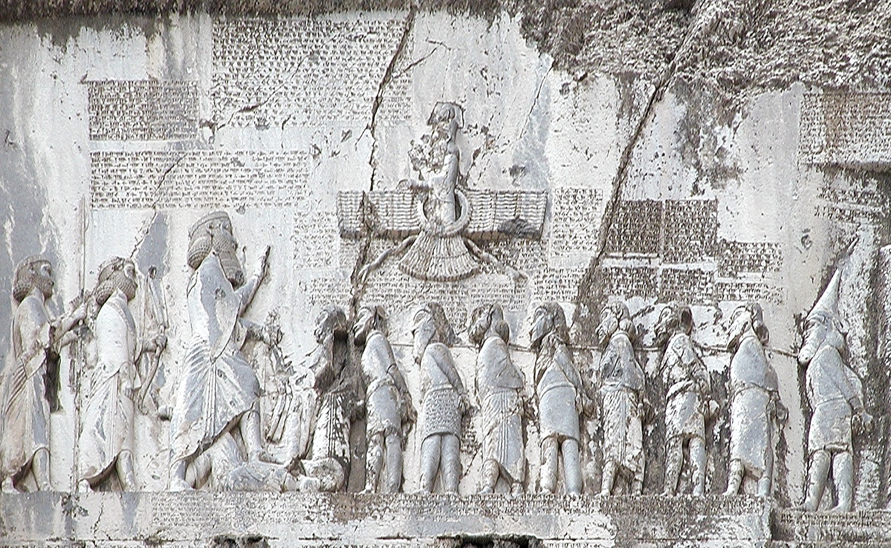( Behistun inscription from Western Iran)
This figure above shows the behistun inscription. It shows King Darius the Great being taller than the other figures. This is interpreted that the Persians are more superior to others and the slaves are to represent the conquered territories of the Persians and King Darius as their master. This shows that Slavery during the Roman Empire was also very unique as slaves could be treated more humanely depending on their slave master, how they can learn a trade during their slavery and become a Roman citizen but can’t hold positions of power since they were originally slaves and it’s only their children that can hold positions of power although surprisingly in some cases some freed slaves attained high positions of power during the reign of Nero.

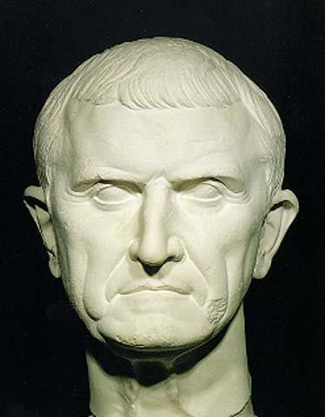(Marcus Licinius Crassus, Roman General who Crushed the Spartacus Rebellion, who later got beheaded by the Parthians.)

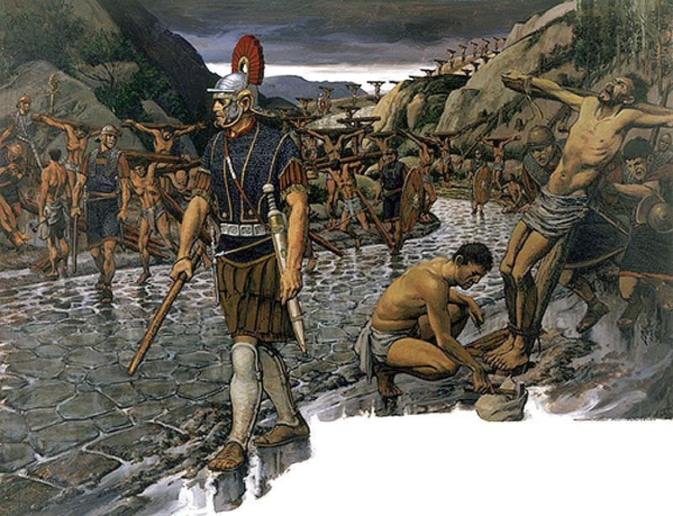(Artists depiction of the Appian way.)
Even though the slave system during Rome sounds humane and better, it’s still slavery and therefore still cruel. Many of the slaves experienced the cruelty of being beaten and the gruelling manual labour they were made to do. And for stronger slaves Was the training of being gladiators as many gladiators had to train rigorously to win and had to win incessantly to earn their freedom. This is why there were three slave revolts as many of the slaves wanted to have revenge on the slave system and to earn their freedom by force. The infamous Spartacus revolt is a good example of slave revolts in the Roman Empire as many slaves(who were gladiators) wanted their freedom but it also shows solidarity to the rebelling slaves as its not only slaves who joined the revolt, many deserted soldiers and farmers who didn’t own land joined the ranks and made Romans underestimate their Danger And when Spartacus was defeated by Crassus, he punished everyone in the rebellion with full sheer brutality, and it was painful and intimidating by the illustration of the appian way crucifixions.(Shown above) This solidarity with the rebelling slaves/gladiators demonstrates the hatred for slavery as an institution of its treatment and brutality but however, in the Spartacus revolt they only wanted their freedom and didn’t care about other slaves in the Roman world which reveals a more selfish side to the revolt itself.
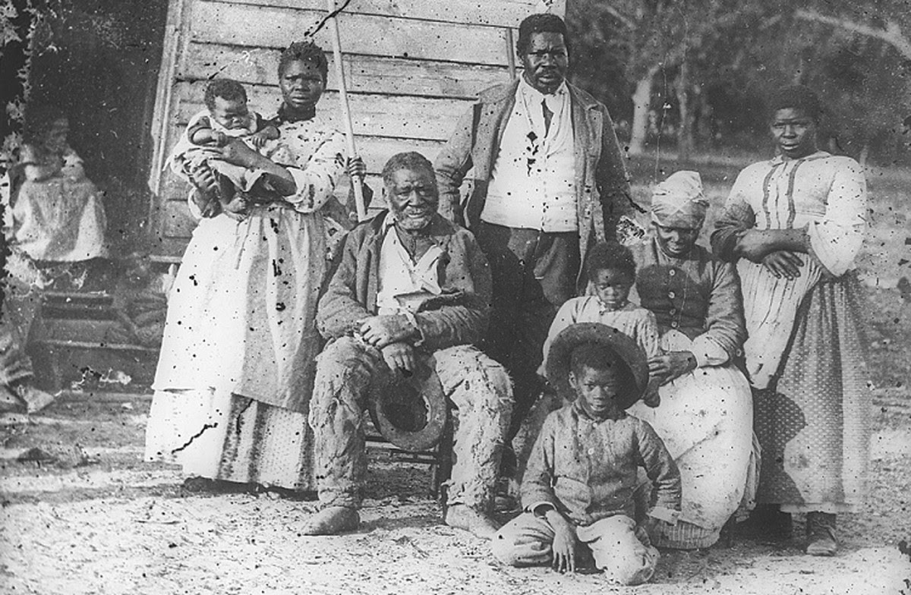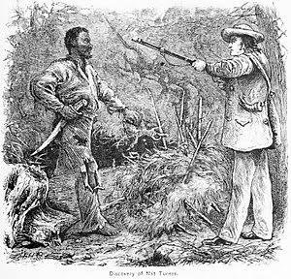(The Discovery of Nat Turner- William Henry Shelton)
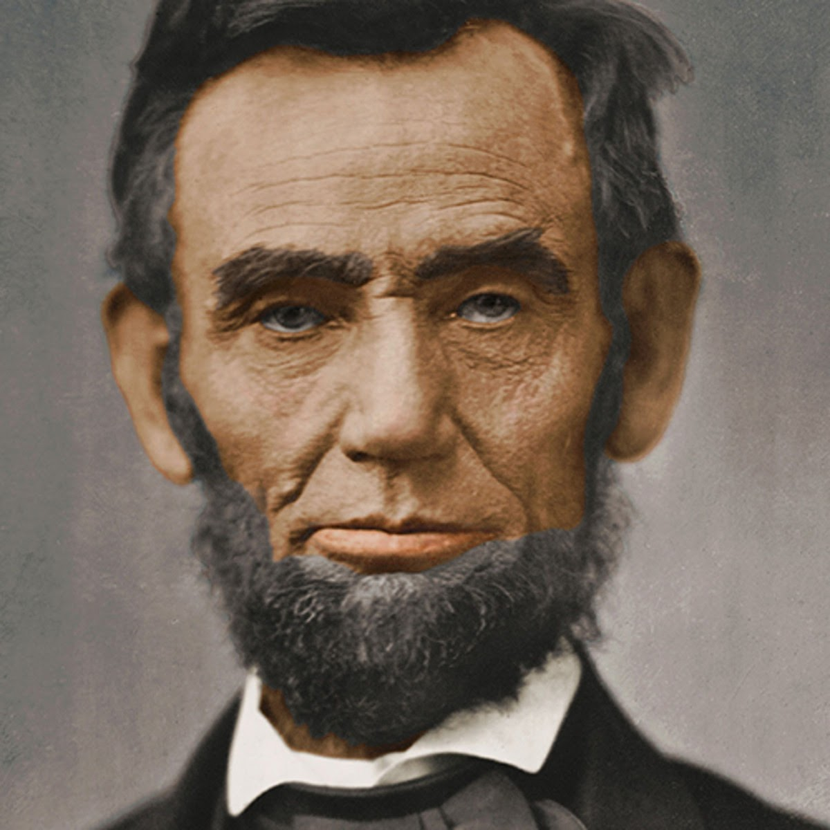(Abraham Lincoln,16th President of the United States from 1861 to his assassination in 1865, proposed the 13th amendment and issued the Emancipation Proclamation during the Early years of the American civil war)
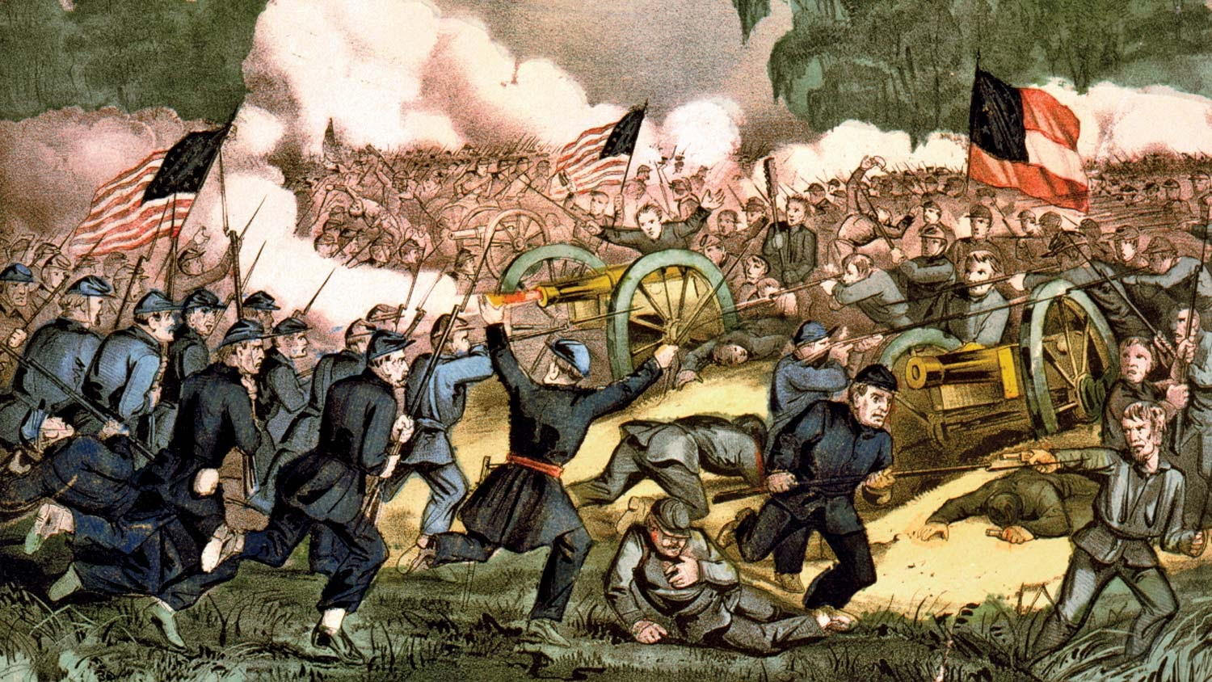( Depiction of the American civil war, 1861-1865)
In Conclusion, Roman Slavery is Somewhat unique compared to other types of slavery throughout history and its practices. As for example the figures above shows references to slavery in 19th century America and how it was more extreme. Both societies took many slaves from their homelands and brought them to where the slave plantations or towns were. Both societies forced slaves to do manual labour such as farming and harvesting crops and endure harsh barbaric punishments if any didn’t comply. Both societies allowed manumission, but it was only the Romans who allowed substantially more manumission to slaves and constantly gave citizenship to many former slaves, while the United States didn’t and only a few rare cases of it happening. Many former slaves learnt a trade during their time in slavery in both societies which allowed them to be skilled and successful. Slavery in the 18/19th centuries had many differences. As for example, children brought to the United States were usually sold off from their families and to never be seen again, in order to be free slaves had to use the Underground Railroad to be free which meant if slaves were caught they could be punished severely, many slaves were auctioned off to other slave masters never to see their families again, all slaves in the United States had no legal protection until Abraham Lincoln became the 16th president in 1861 and issued the emancipation proclamation and proposed the thirteenth amendment during the American civil war. One other similarity between the two civilisations is there was resentment to slavery by both slaves and northern abolitionists which culminated into 250 attempted uprisings which ultimately resulted in the bloodiest conflict in American history. One example of those 250 attempted slave uprisings is one led by a rebelling and escaped slave named Nat Turner(seen under the photo of the slave family) while, another example of those 250 attempted uprisings is a raid on Harper’s ferry by an American settler and radical abolitionist named John Brown to start a slave uprising in the Southern States. (But slavery is also a cause of conflict between the white American settlers in the American territories and states such as a conflict in the Kansas and Nebraska territories called bleeding Kansas also instigated by John Brown as well with the help of his son’s.) These events of slavery’s resentment in the United States ultimately led to the creation of the Confederate Nation and the Country’s bloodiest conflict in its history aka the American civil war and this serves as an illustration that resentment of slavery can turn a nation against each other and can plunge it into division and further fuelling to war/rebellion. One small difference is that only the modern society has abolished slavery as an institution, But the one ultimate, fundamental and common similarity the Ancient and Modern time periods have was slavery in general was resented altogether as an institution and this resentment of slavery still continues to this day from past to present.

